Install GIT & make sure it is added into PATH.

Section 0 -Use GIT as local VCS. Steps to follow:

1. Create a directory ‘project_dir’ & cd to ‘project_dir’.

Ans- pjadha20@LIN51006801 MINGW64 ~/Desktop

$ mkdir project_dir

pjadha20@LIN51006801 MINGW64 ~/Desktop

$ cd project_dir

1. Initialize git version database.(git init)

Ans- PJADHA20@LIN51006801 MINGW64 ~/Desktop/project_dir

$ git init

Initialized empty Git repository in C:/Users/PJADHA20/Desktop/project_dir/.git/

1. Create a new file index.html.

Ans- C:/Users/hp/project_dir/index.html – Index.html file is created

PJADHA20@LIN51006801 MINGW64 ~/Desktop/project_dir (master)

$ Touch index.html

1. Check the git status. You should find index.html as untracked file.

Ans- PJADHA20@LIN51006801 MINGW64 ~/Desktop/project_dir (master)

$ git status

On branch master

No commits yet

Untracked files:

(use "git add <file>..." to include in what will be committed)

index.html

nothing added to commit but untracked files present (use "git add" to track)

1. Stage the index.html file.

Ans- PJADHA20@LIN51006801 MINGW64 ~/Desktop/project_dir (master)

$ git add .

PJADHA20@LIN51006801 MINGW64 ~/Desktop/project_dir (master)

$ git status

On branch master

No commits yet

Changes to be committed:

(use "git rm --cached <file>..." to unstage)

new file: index.html

1. Commit index.html

Ans- PJADHA20@LIN51006801 MINGW64 ~/Desktop/project_dir (master)

$ git config --global user.email "pbj8007@gmail.com"

PJADHA20@LIN51006801 MINGW64 ~/Desktop/project_dir (master)

$ git commit -m "first commit"

[master (root-commit) 42f6d99] first commit

1 file changed, 0 insertions(+), 0 deletions(-)

create mode 100644 index.html

1. Make few changes in index.html & create a new file info.txt file.

Ans- PJADHA20@LIN51006801 MINGW64 ~/Desktop/project_dir (master)

$ touch info.txt

1. Check git status. You should find index.html &info.txt as untracked files.

Ans - PJADHA20@LIN51006801 MINGW64 ~/Desktop/project_dir (master)

$ git status

On branch master

Changes not staged for commit:

(use "git add <file>..." to update what will be committed)

(use "git restore <file>..." to discard changes in working directory)

modified: index.html

Untracked files:

(use "git add <file>..." to include in what will be committed)

info.txt

no changes added to commit (use "git add" and/or "git commit -a")

1. Configure GIT to ignore all txt files.

Ans- PJADHA20@LIN51006801 MINGW64 ~/Desktop/project_dir (master)

$ touch .gitignore

1. Again check the git status. You should find only index.html as untracked file.

Ans -PJADHA20@LIN51006801 MINGW64 ~/Desktop/project_dir (master)

$ git status

On branch master

Changes to be committed:

(use "git restore --staged <file>..." to unstage)

modified: index.html

Untracked files:

(use "git add <file>..." to include in what will be committed)

.gitignore

README.md/

index1.html

info.txt

1. State & commit index.html

Ans- PJADHA20@LIN51006801 MINGW64 ~/Desktop/project_dir (master)

$ git add index.html

pjadha20@LIN51006801 MINGW64 ~/Desktop/project_dir (master)

$ git commit -m "index file commited"

[master a463dce] index file commited

1 file changed, 9 insertions(+)

1. Log all your comments so far.

Ans-

PJADHA20@LIN51006801 MINGW64 ~/Desktop/project_dir (master)

$ git –all

unknown option: --all

usage: git [--version] [--help] [-C <path>] [-c <name>=<value>]

[--exec-path[=<path>]] [--html-path] [--man-path] [--info-path]

[-p | --paginate | -P | --no-pager] [--no-replace-objects] [--bare]

[--git-dir=<path>] [--work-tree=<path>] [--namespace=<name>]

[--super-prefix=<path>] [--config-env=<name>=<envvar>]

<command> [<args>]

1. Make some changes in index.html.

PJADHA20@LIN51006801 MINGW64 ~/Desktop/project_dir (master)

$ Vi index.html

PJADHA20@LIN51006801 MINGW64 ~/Desktop/project_dir (master)

$ git commit -m "chaned in index files"

On branch master

Changes not staged for commit:

(use "git add <file>..." to update what will be committed)

(use "git restore <file>..." to discard changes in working directory)

modified: index.html

Untracked files:

(use "git add <file>..." to include in what will be committed)

.gitignore

info.txt

no changes added to commit (use "git add" and/or "git commit -a")

PJADHA20@LIN51006801 MINGW64 ~/Desktop/project_dir (master)

$ git commit

On branch master

Changes not staged for commit:

(use "git add <file>..." to update what will be committed)

(use "git restore <file>..." to discard changes in working directory)

modified: index.html

Untracked files:

(use "git add <file>..." to include in what will be committed)

.gitignore

info.txt

no changes added to commit (use "git add" and/or "git commit -a")

1. Revert the change made in the previous step using git command.

PJADHA20@LIN51006801 MINGW64 ~/Desktop/project_dir (master)

$ git diff head

**diff --git a/index.html b/index.html**

**index ccf0537..40da05d 100644**

**--- a/index.html**

**+++ b/index.html**

@@ -1,3 +1,6 @@

+i

+

+

<!DOCTYPE html>

<html>

<head>

@@ -5,5 +8,7 @@

</head>

<body>

<h1>git demo file.</h1>

+ <p>new para</p>

+

</body>

-</html>

\ No newline at end of file

+</htm>

1. Again change index.html.

PJADHA20@LIN51006801 MINGW64 ~/Desktop/project_dir (master)

$ vi index.html

1. Stage index.html

PJADHA20@LIN51006801 MINGW64 ~/Desktop/project_dir (master)

$ git add index.html

1. Revert back the last stage.

$ git log --oneline

a463dce (HEAD -> master) index file commited

42f6d99 first commit

PJADHA20@LIN51006801 MINGW64 ~/Desktop/project_dir (master)

$ git reset 42f6d99

Unstaged changes after reset:

M index.html

1. Rename ‘add’ command to ‘my-add’.

PJADHA20@LIN51006801 MINGW64 ~/Desktop/project_dir/project_dir (lt)

$ git mv add my-add

PJADHA20@LIN51006801 MINGW64 ~/Desktop/project_dir/project_dir (lt)

$ git status

On branch lt

No commits yet

Changes to be committed:

(use "git rm --cached <file>..." to unstage)

new file: index.html

Untracked files:

(use "git add <file>..." to include in what will be committed)

my-add

1. Using my_add command Stage index.html again & commit the changes.

PJADHA20@LIN51006801 MINGW64 ~/Desktop/project_dir/project_dir (lt)

$ git add .

PJADHA20@LIN51006801 MINGW64 ~/Desktop/project_dir/project_dir (lt)

$ git commit -m"change by adding"

[lt (root-commit) 050e450] change by adding

2 files changed, 0 insertions(+), 0 deletions(-)

create mode 100644 index.html

create mode 100644 my-add

PJADHA20@LIN51006801 MINGW64 ~/Desktop/project_dir/project_dir (lt)

$ git commit

[master 817ee9f] all commit files.

3 files changed, 15 insertions(+)

create mode 100644 .gitignore

create mode 100644 info.txt

1. Revert the last commit.

PJADHA20@LIN51006801 MINGW64 ~/Desktop/project_dir/project_dir (lt)

$ git log --oneline

050e450 (HEAD -> lt) change by adding

PJADHA20@LIN51006801 MINGW64 ~/Desktop/project_dir/project_dir (lt)

$ git reset 050e450

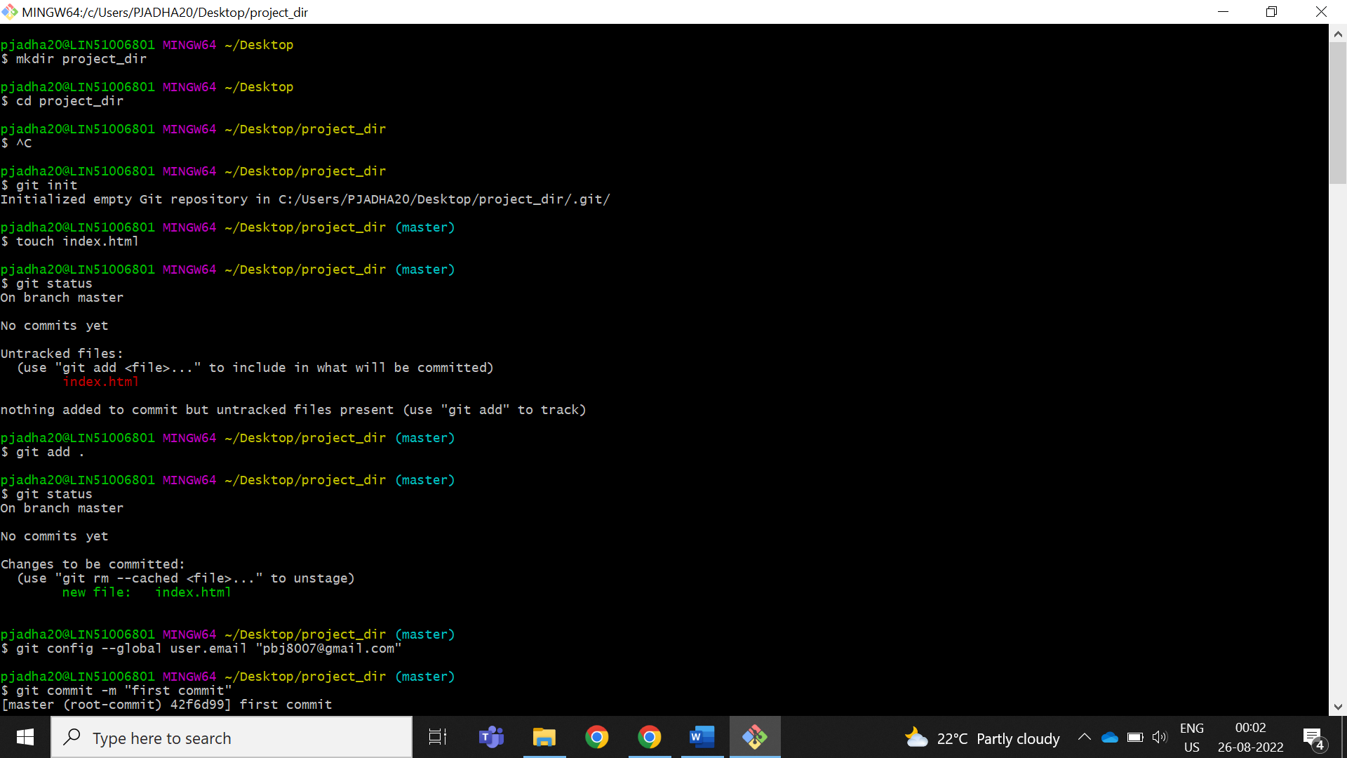

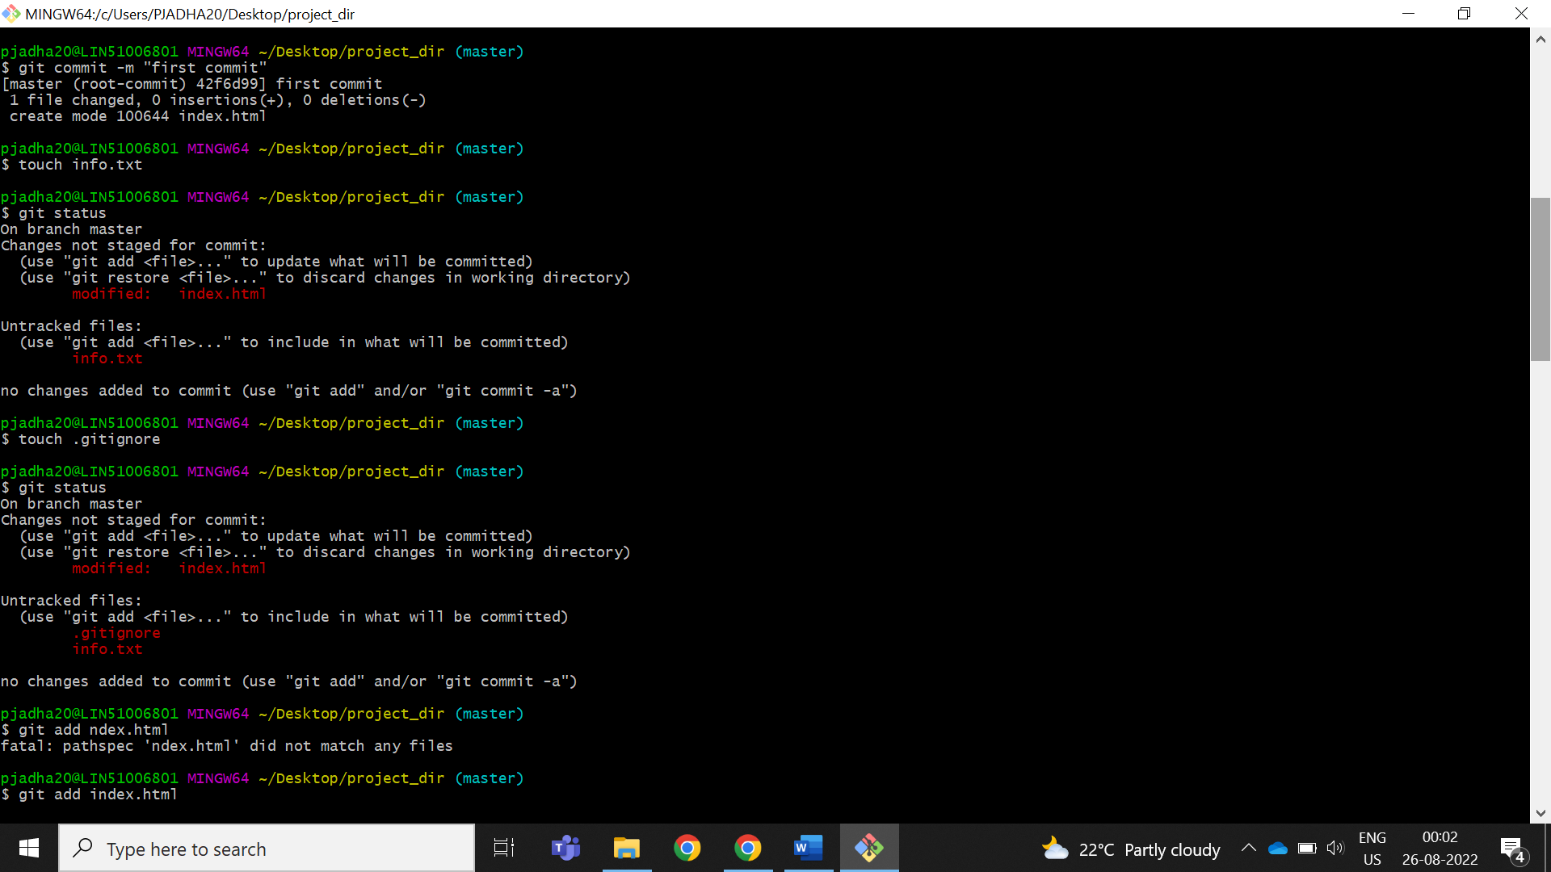

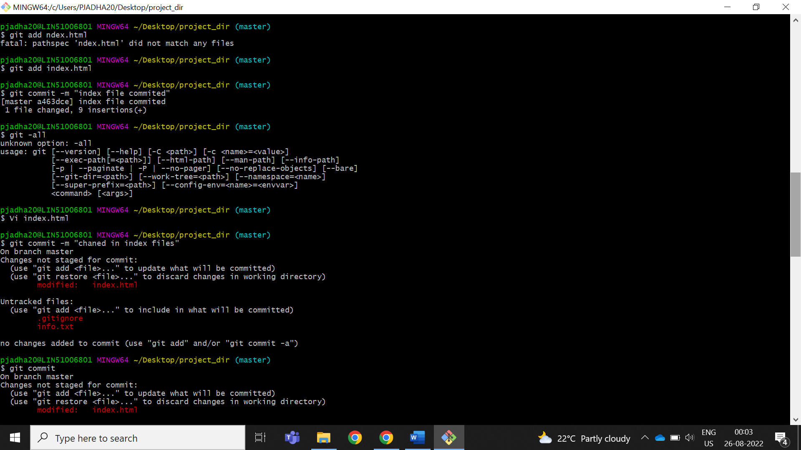

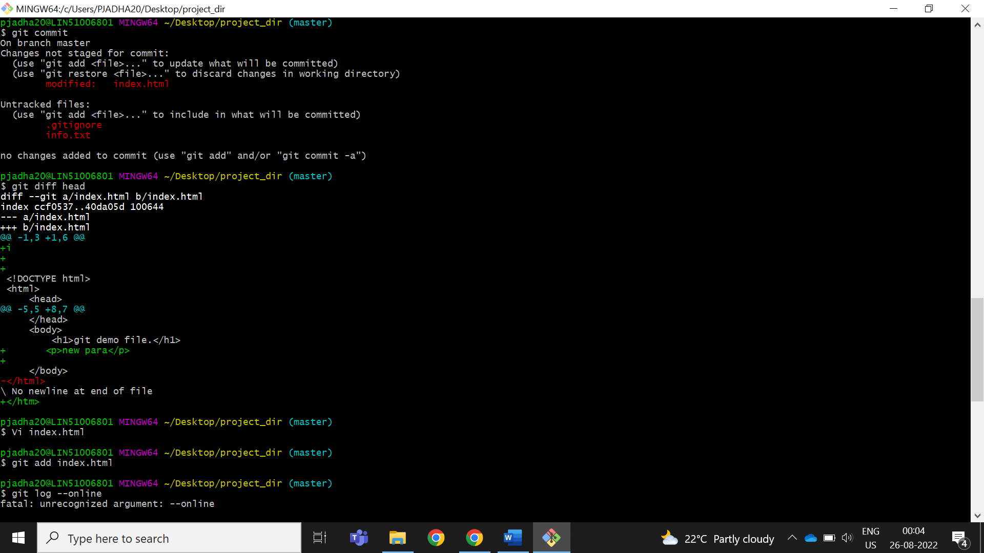

git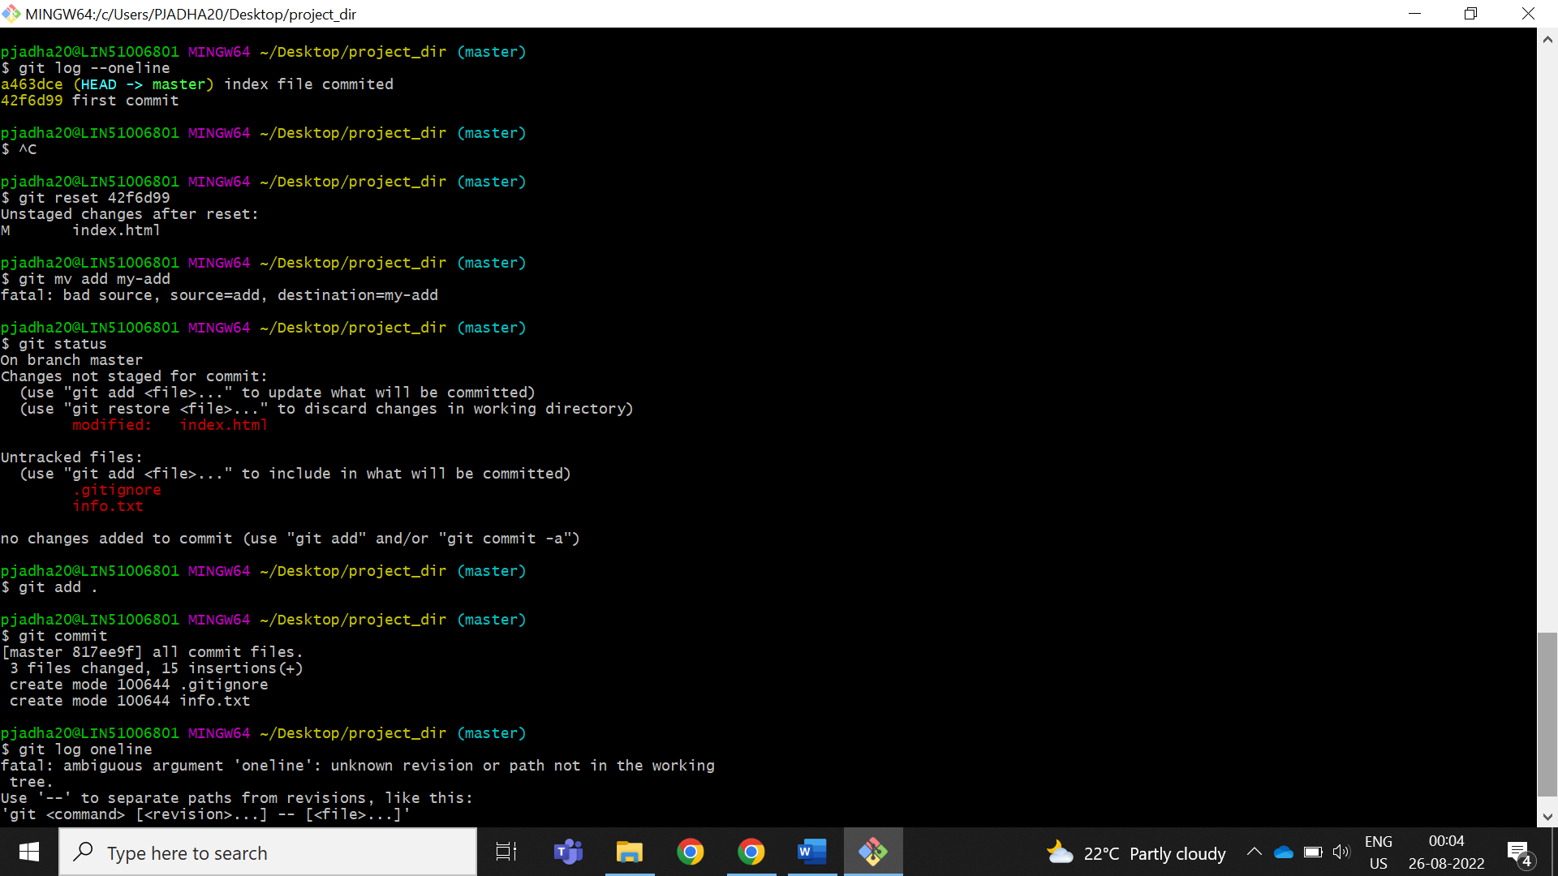

*GIT Branching*

Objective: Commit HTML, CSS & JavaScript assignments into GIT.

SECTION-1 (HTML assignments) - Steps to follow:

1. First take a backup of your assignments & projects. This is required because due to incorrect GIT operation you may lose your files.

Answer**-** cp -r myrepo backup_copy

1. Create an empty directory ‘Assignments’ & cd to ‘Assignments’

Ans-

pjadha20@LIN51006801 MINGW64 ~/Desktop

$ mkdir Assignments

pjadha20@LIN51006801 MINGW64 ~/Desktop

$ cd Assignments

pjadha20@LIN51006801 MINGW64 ~/Desktop/Assignments

$ git init

Initialized empty Git repository in C:/Users/PJADHA20/Desktop/Assignments/.git/

1. Create a file README.txt inside ‘Assignments’ & write few lines about the contents of ‘Assignments’ folder.

PJADHA20@LIN51006801 MINGW64 ~/Desktop/Assignments (master)

$ touch README.txt

1. Commit README.txt file.

PJADHA20@LIN51006801 MINGW64 ~/Desktop/Assignments (master)

$ git add README.txt

PJADHA20@LIN51006801 MINGW64 ~/Desktop/Assignments (master)

$ git commit -m "add readme file"

[master (root-commit) d0eae1d] add readme file

1 file changed, 0 insertions(+), 0 deletions(-)

create mode 100644 README.txt

1. Now create a new branch ‘html-assignments’.

PJADHA20@LIN51006801 MINGW64 ~/Desktop/Assignments (master)

$ git branch html-assignments

1. Switch to ‘html-assignments’ branch.

PJADHA20@LIN51006801 MINGW64 ~/Desktop/Assignments (master)

$ git checkout html-assignments

Switched to branch 'html-assignments'

1. Copy all HTML assignments inside ‘Assignments’ folder.

PJADHA20@LIN51006801 MINGW64 ~/Desktop/Assignments (html-assignments)

$ git commit -m "copy the file"

On branch html-assignments

Untracked files:

(use "git add <file>..." to include in what will be committed)

everyday.html

nothing added to commit but untracked files present (use "git add" to track)

1. Commit HTML assignments into ‘html-assignments’ branch.

hp@DESKTOP-JAB1NLP MINGW64 ~/Desktop/Assignments (html-assignments)

$ git add .

PJADHA20@LIN51006801 MINGW64 ~/Desktop/Assignments (html-assignments)

$ git commit -m "change html files"

[html-assignments cd4f5be] change html files

1 file changed, 460 insertions(+)

create mode 100644 everyday.html

PJADHA20@LIN51006801 MINGW64 ~/Desktop/Assignments (html-assignments)

$ git commit

On branch html-assignments

nothing to commit, working tree clean

1. Make minor changes into few files belonging to ‘html-assignments’ branch.

Ans- I had made some changes manually.

1. Commit those changed files.

PJADHA20@LIN51006801 MINGW64 ~/Desktop/Assignments (html-assignments)

$ git commit -m "i changes"

On branch html-assignments

nothing to commit, working tree clean

PJADHA20@LIN51006801 MINGW64 ~/Desktop/Assignments (html-assignments)

$ git commit

On branch html-assignments

nothing to commit, working tree clean

1. Switch to master branch.

PJADHA20@LIN51006801 MINGW64 ~/Desktop/Assignments (html-assignments)

$ git checkout master

Switched to branch 'master'

1. Make minor changes into README.txt file & commit those changes into master.

PJADHA20@LIN51006801 MINGW64 ~/Desktop/Assignments (master)

$ git add .

PJADHA20@LIN51006801 MINGW64 ~/Desktop/Assignments (master)

$ git commit -m "change in readme"

On branch master

nothing to commit, working tree clean

PJADHA20@LIN51006801 MINGW64 ~/Desktop/Assignments (master)

$ git commit

On branch master

nothing to commit, working tree clean

1. Again switch to ‘html-assignments’ branch.

PJADHA20@LIN51006801 MINGW64 ~/Desktop/Assignments (master)

$ git checkout html-assignments

Switched to branch 'html-assignments'

1. Make minor changes into few files belonging to ‘html-assignments’ branch.

Ans- I had made some changes manually.

1. Commit those changes.

PJADHA20@LIN51006801 MINGW64 ~/Desktop/Assignments (html-assignments)

$ git commit -m "i changes"

On branch html-assignments

nothing to commit, working tree clean

PJADHA20@LIN51006801 MINGW64 ~/Desktop/Assignments (html-assignments)

$ git commit

On branch html-assignments

nothing to commit, working tree clean

1. Switch to master.

PJADHA20@LIN51006801 MINGW64 ~/Desktop/Assignments (html-assignments)

$ git checkout master

Switched to branch 'master'

1. Merge ‘html-assignments’ branch into master. Confirm all html assignments are shown in master.

PJADHA20@LIN51006801 MINGW64 ~/Desktop/Assignments (master)

$ git merge html-assignments

Updating 79f960e..cd4f5be

Fast-forward

everyday.html | 460 ++++++++++++++++++++++++++++++++++++++++++++++++++++++++++

1 file changed, 460 insertions(+)

create mode 100644 everyday.html

1. Finally delete the ‘html-assignments’ branch.

PJADHA20@LIN51006801 MINGW64 ~/Desktop/Assignments (master)

$ git branch -d html-assignments

Deleted branch html-assignments (was d0eae1d).

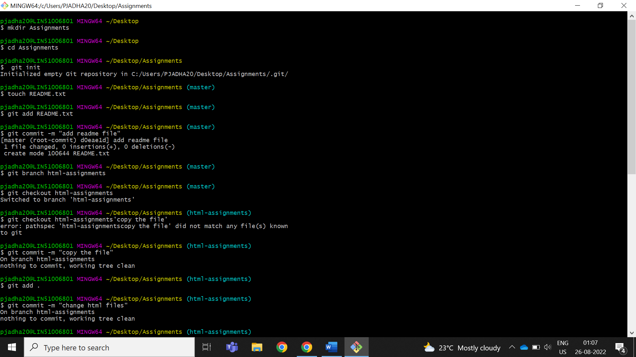

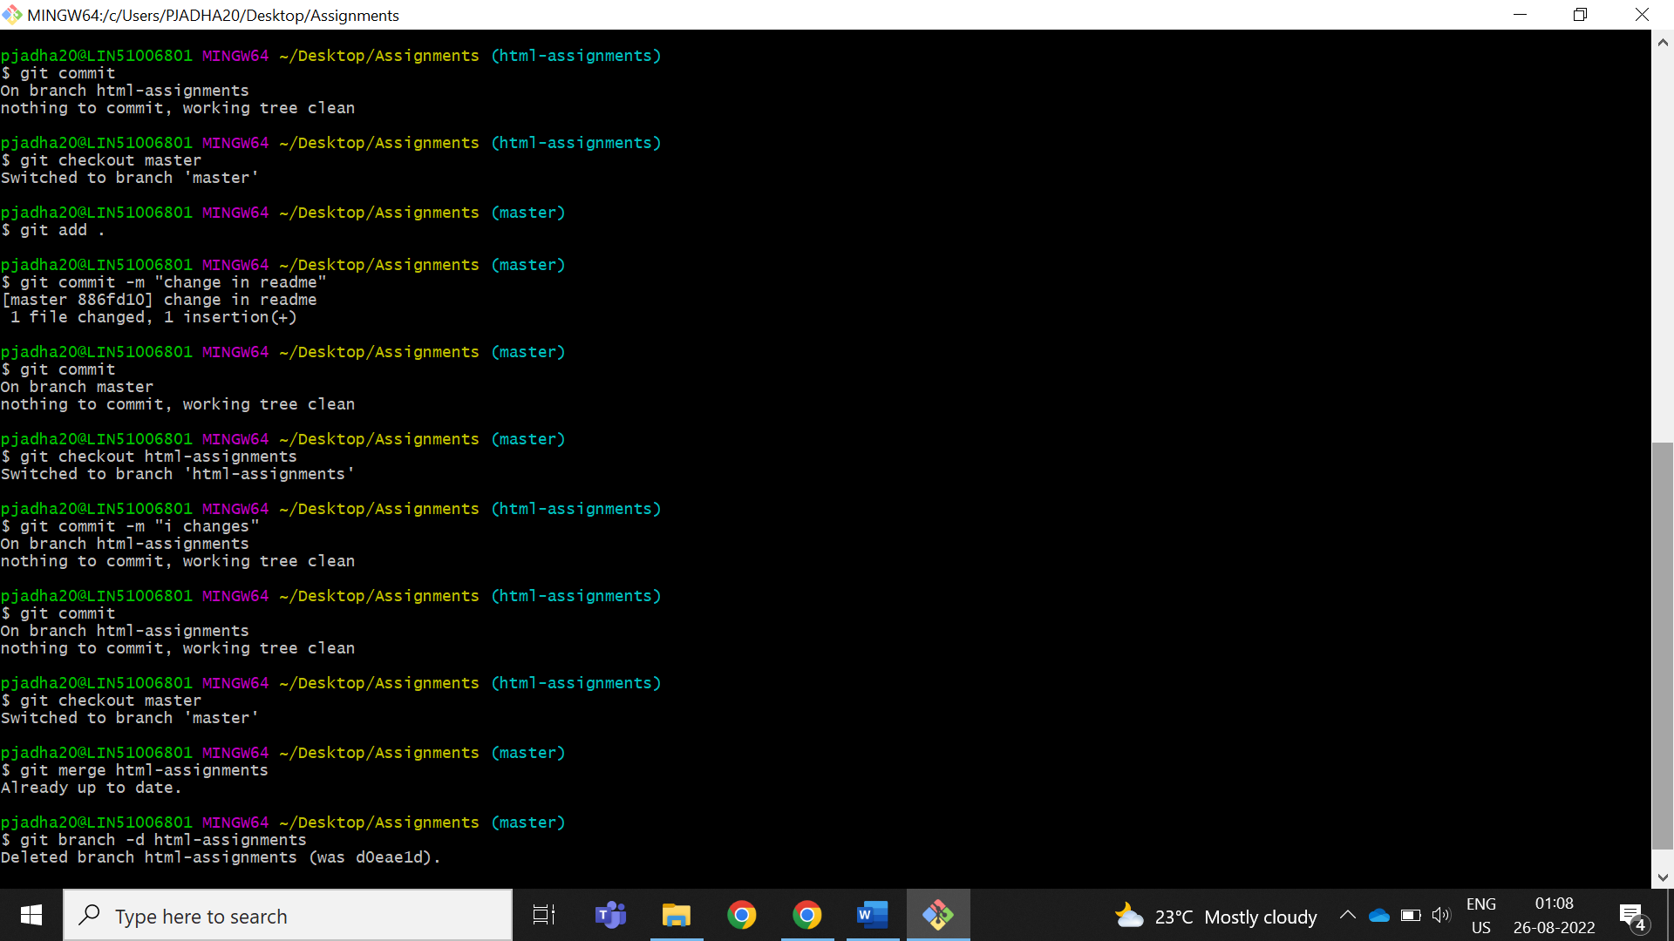

SECTION-2 - (CSS assignments) Steps to follow:

1. Create a new branch ‘css-assignments’.

PJADHA20@LIN51006801 MINGW64 ~/Desktop/Assignments (master)

$ git branch css-assignments

1. Switch to ‘css-assignments’ branch.

PJADHA20@LIN51006801 MINGW64 ~/Desktop/Assignments (master)

$ git checkout css-assignments

Switched to branch 'css-assignments'

1. Copy all CSS assignments inside ‘Assignments’ folder.

PJADHA20@LIN51006801 MINGW64 ~/Desktop/Assignments (css-assignments)

$ git commit -m "copy the file"git

On branch css-assignments

Untracked files:

(use "git add <file>..." to include in what will be committed)

docbook-xsl.css

nothing added to commit but untracked files present (use "git add" to track)

1. Commit CSS assignments into ‘css-assignments’ branch.

PJADHA20@LIN51006801 MINGW64 ~/Desktop/Assignments (css-assignments)

$ git add .

pjadha20@LIN51006801 MINGW64 ~/Desktop/Assignments (css-assignments)

$ git commit -m "added css file"

[css-assignments e3c8d06] added css file

1 file changed, 0 insertions(+), 0 deletions(-)

create mode 100644 style.css

1. Make minor changes into README.txt file on line 1 belonging to ‘css-assignments’ branch.

Ans- I had made some changes manually.

$ git status

On branch css-assignments

Changes not staged for commit:

(use "git add <file>..." to update what will be committed)

(use "git restore <file>..." to discard changes in working directory)

modified: README.txt

no changes added to commit (use "git add" and/or "git commit -a")

1. Commit those changed files.

PJADHA20@LIN51006801 MINGW64 ~/Desktop/Assignments (css-assignments)

$ git add .

PJADHA20@LIN51006801 MINGW64 ~/Desktop/Assignments (css-assignments)

$ git commit -m "change readme files"

[css-assignments bc66041] change readme files

1 file changed, 2 insertions(+), 1 deletion(-)

PJADHA20@LIN51006801 MINGW64 git status ~/Desktop/Assignments (css-assignments)

$ git commit

On branch css-assignments

nothing to commit, working tree clean

1. Switch to master branch.

PJADHA20@LIN51006801 MINGW64 ~/Desktop/Assignments (css-assignments)

$ git checkout master

Switched to branch 'master'

1. Make minor changes into README.txt file on line 3 & commit those changes into master.

Ans- I had made some changes manually.

1. Again switch to ‘css-assignments’ branch.

PJADHA20@LIN51006801 MINGW64 ~/Desktop/Assignments (master)

$ git checkout css-assignments

Switched to branch 'css-assignments'

1. Make minor changes into few files belonging to ‘css-assignments’ branch.

Ans- I had made some changes manually.

1. Commit those changes.

PJADHA20@LIN51006801 MINGW64 ~/Desktop/Assignments (css-assignments)

$ git add .

PJADHA20@LIN51006801 MINGW64 ~/Desktop/Assignments (css-assignments)

$ git commit -m "change in css"

[css-assignments 60ce076] change in css

1 file changed, 3 insertions(+)

pjadha20@LIN51006801 MINGW64 ~/Desktop/Assignments (css-assignments)

$ git commit

On branch css-assignments

nothing to commit, working tree clean

1. Switch to master.

PJADHA20@LIN51006801 MINGW64 ~/Desktop/Assignments (css-assignments)

$ git checkout master

Switched to branch 'master'

1. Merge ‘css-assignments’ branch into master. Confirm all css assignments are shown in master.

$ git merge css-assignments

Updating 4bc4fff..60ce076

Fast-forward

README.txt | 2 ++

style.css | 3 +++

2 files changed, 5 insertions(+)

create mode 100644 README.txt

create mode 100644 style.css

1. Finally delete the ‘css-assignments’ branch.

PJADHA20@LIN51006801 MINGW64 ~/Desktop/Assignments (master)

$ git branch -d css-assignments

Deleted branch css-assignments (was 60ce076).

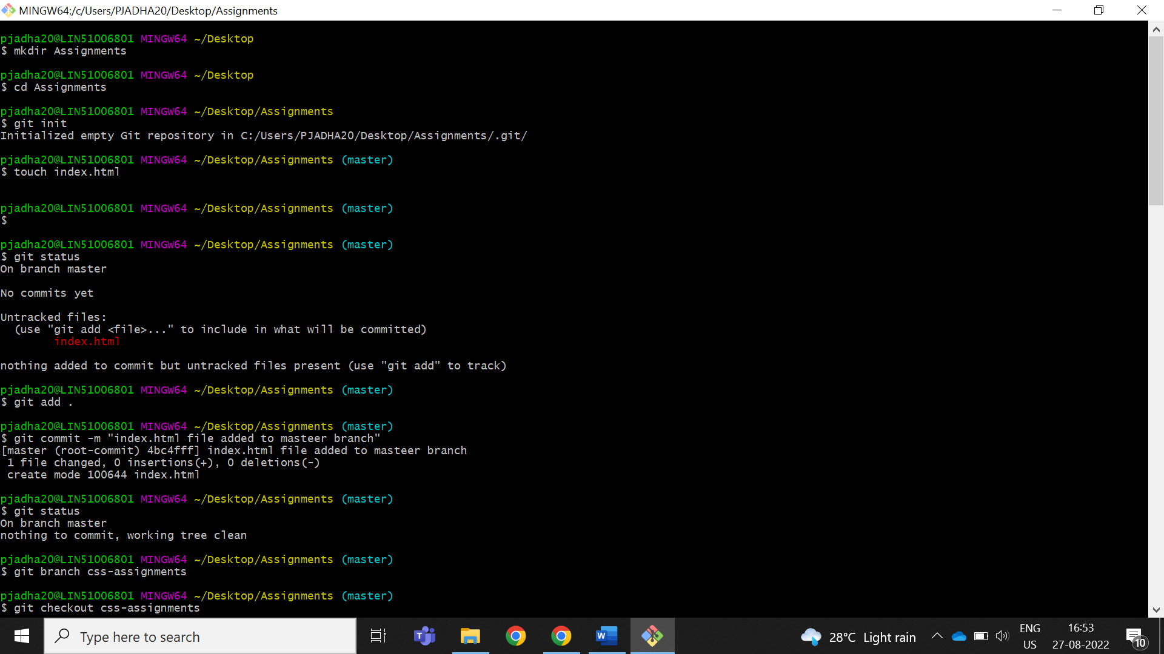

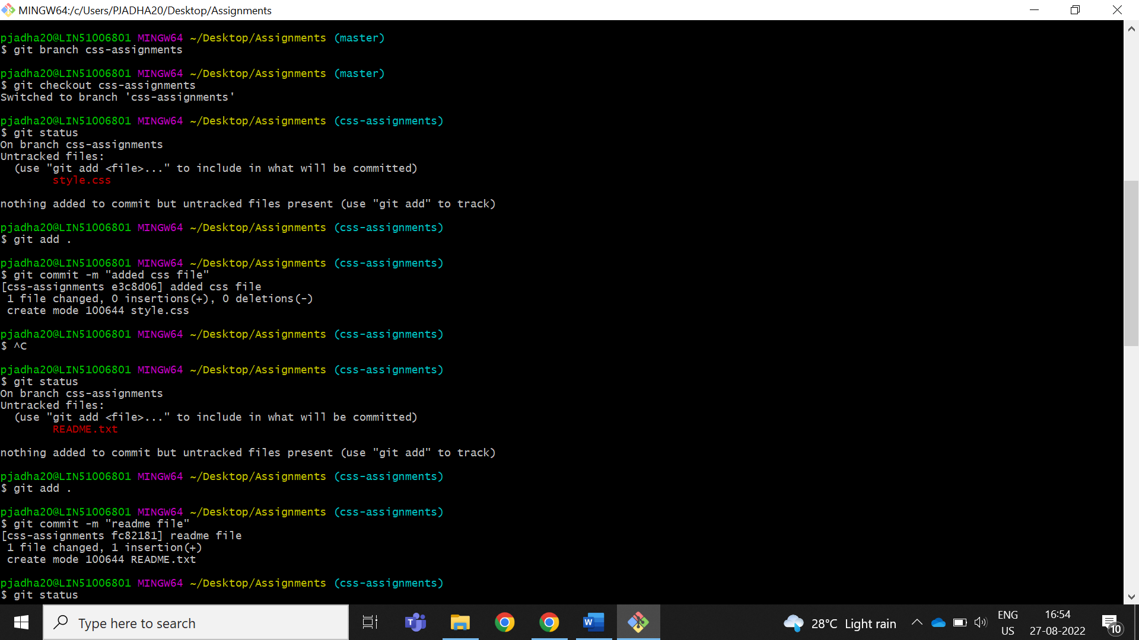

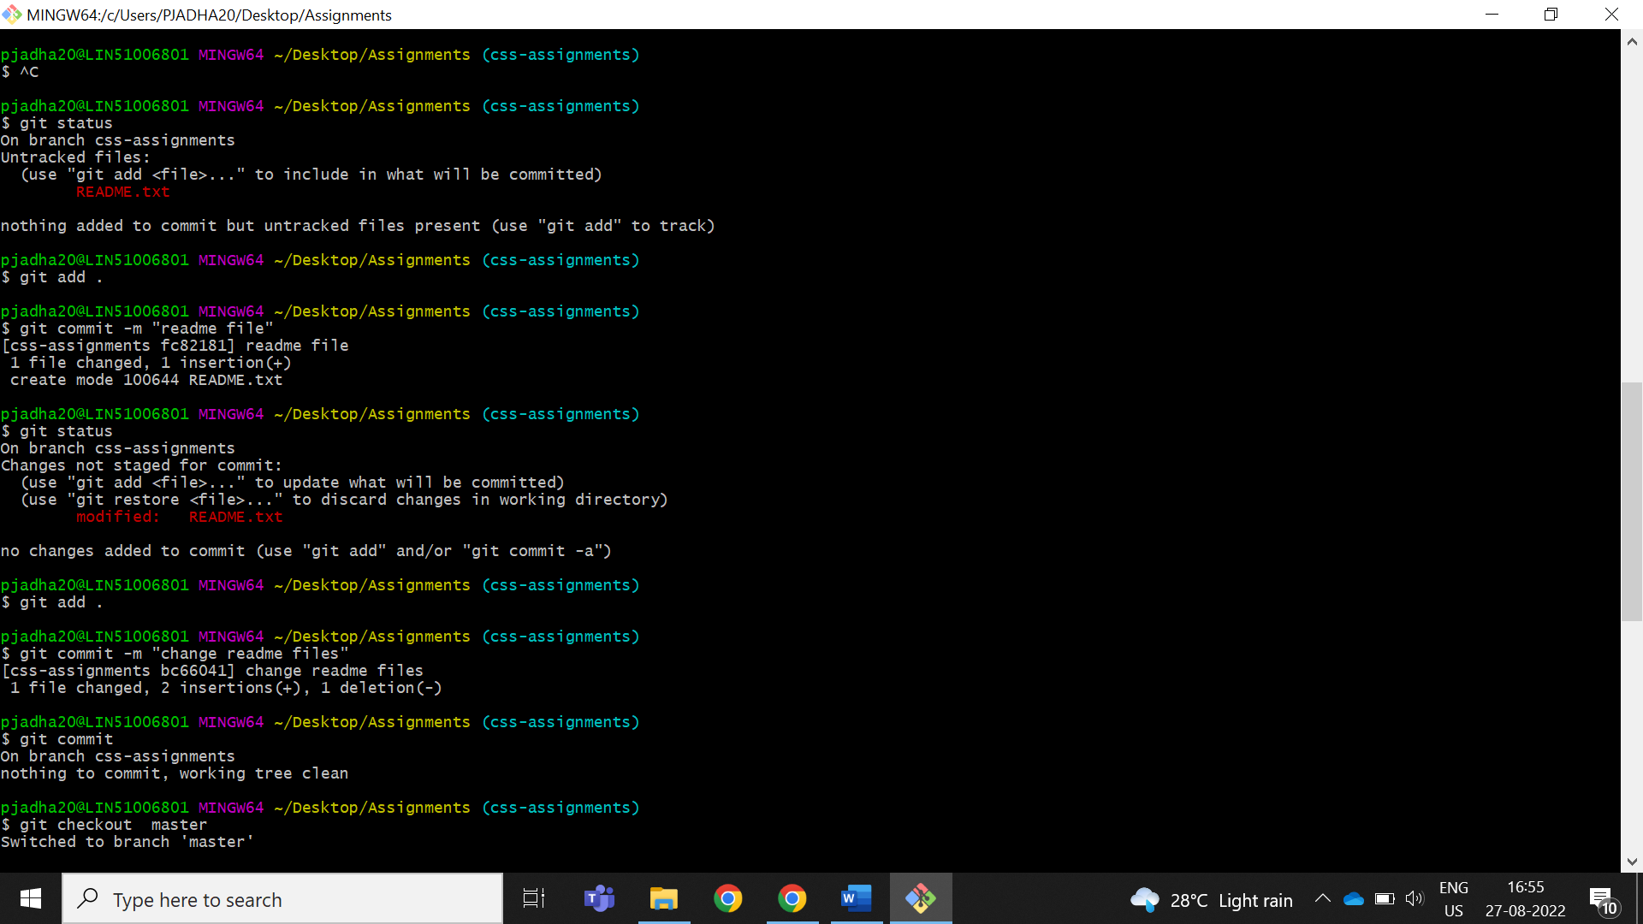

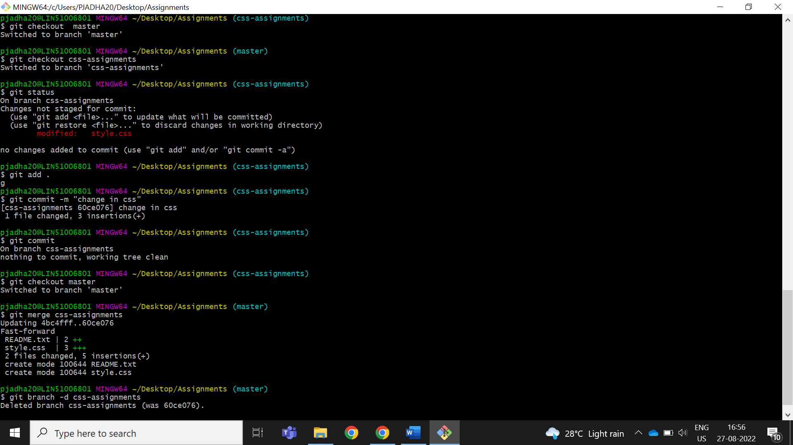

SECTION-3 - (JavaScript assignments) Steps to follow:

1. Create a new branch ‘js-assignments’.

PJADHA20@LIN51006801 MINGW64 ~/Desktop/Assignments (master)

$ git branch js-assignments

1. Switch to ‘js-assignments’ branch.

PJADHA20@LIN51006801 MINGW64 ~/Desktop/Assignments (master)

$ git checkout js-assignments

Switched to branch 'js-assignments'

1. Copy all JavaScript assignments inside ‘Assignments’ folder.

PJADHA20@LIN51006801 MINGW64 ~/Desktop/Assignments (js-assignments)

$ git status

On branch js-assignmnents

Untracked files:

(use "git add <file>..." to include in what will be committed)

first.js

nothing added to commit but untracked files present (use "git add" to track)

1. Commit JavaScript assignments into ‘js-assignments’ branch

pjadha20@LIN51006801 MINGW64 ~/Desktop/Assignments (js-assignmnents)

$ git add .

pjadha20@LIN51006801 MINGW64 ~/Desktop/Assignments (js-assignmnents)

$ git commit -m "added js files"

[js-assignmnents 9c36f90] added js files

1 file changed, 2 insertions(+)

create mode 100644 first.js

pjadha20@LIN51006801 MINGW64 ~/Desktop/Assignments (js-assignmnents)

$ git commit

On branch js-assignmnents

nothing to commit, working tree clean

1. Make minor changes into README.txt file on line 1 belonging to ‘js-assignments’ branch.

Ans- I had made some changes manually.

$ git status

On branch js-assignmnents

Changes not staged for commit:

(use "git add <file>..." to update what will be committed)

(use "git restore <file>..." to discard changes in working directory)

modified: README.txt

no changes added to commit (use "git add" and/or "git commit -a")

1. Commit those changed files.

PJADHA20@LIN51006801 MINGW64 ~/Desktop/Assignments (js-assignments)

$ git add .

pjadha20@LIN51006801 MINGW64 ~/Desktop/Assignments (js-assignmnents)

$ git commit -m "change in readme file"

[js-assignmnents bd4fcc0] change in readme file

1 file changed, 2 insertions(+), 1 deletion(-)

pjadha20@LIN51006801 MINGW64 ~/Desktop/Assignments (js-assignmnents)

$ git commit

On branch js-assignmnents

nothing to commit, working tree clean

1. Switch to master branch.

PJADHA20@LIN51006801 MINGW64 ~/Desktop/Assignments (js-assignments)

$ git checkout master

Switched to branch 'master'

1. Make minor changes into README.txt file on line 1 & commit those changes into master.

Ans- I had made some changes manually.

pjadha20@LIN51006801 MINGW64 ~/Desktop/Assignments (master)

$ git status

On branch master

Changes not staged for commit:

(use "git add <file>..." to update what will be committed)

(use "git restore <file>..." to discard changes in working directory)

modified: README.txt

no changes added to commit (use "git add" and/or "git commit -a")

pjadha20@LIN51006801 MINGW64 ~/Desktop/Assignments (master)

$ git add .

pjadha20@LIN51006801 MINGW64 ~/Desktop/Assignments (master)

$ git commit -m "changes in js-readme "

[master 7fc1a01] changes in js-readme

1 file changed, 3 insertions(+), 1 deletion(-)

pjadha20@LIN51006801 MINGW64 ~/Desktop/Assignments (master)

$ git commit

On branch master

nothing to commit, working tree clean

1. Again switch to ‘js-assignments’ branch.

PJADHA20@LIN51006801 MINGW64 ~/Desktop/Assignments (master)

$ git checkout js-assignments

Switched to branch 'js-assignments'

1. Make minor changes into few files belonging to ‘js-assignments’ branch.

Ans- In js-assignment branch I had made some changes in the manually.

pjadha20@LIN51006801 MINGW64 ~/Desktop/Assignments (js-assignmnents)

$ git status

On branch js-assignmnents

Changes not staged for commit:

(use "git add <file>..." to update what will be committed)

(use "git restore <file>..." to discard changes in working directory)

modified: first.js

modified: style.css

no changes added to commit (use "git add" and/or "git commit -a")

1. Commit those changes.

pjadha20@LIN51006801 MINGW64 ~/Desktop/Assignments (js-assignmnents)

$ git add .

pjadha20@LIN51006801 MINGW64 ~/Desktop/Assignments (js-assignmnents)

$ git commit -m "changs in two files"

[js-assignmnents db1217b] changs in two files

2 files changed, 7 insertions(+), 2 deletions(-)

pjadha20@LIN51006801 MINGW64 ~/Desktop/Assignments (js-assignmnents)

$ git commit

On branch js-assignmnents

nothing to commit, working tree clean

1. Switch to master.

PJADHA20@LIN51006801 MINGW64 ~/Desktop/Assignments (js-assignments)

$ git checkout master

Switched to branch 'master'

1. Merge ‘js-assignments’ branch into master. Confirm all JavaScript assignments are shown in master.

pjadha20@LIN51006801 MINGW64 ~/Desktop/Assignments (master)

$ git merge js-assignmnents

Already up to date.

1. Finally delete the ‘js-assignments’ branch.

pjadha20@LIN51006801 MINGW64 ~/Desktop/Assignments (master)

$ git branch -d js-assignmnents

Deleted branch js-assignmnents (was db1217b).

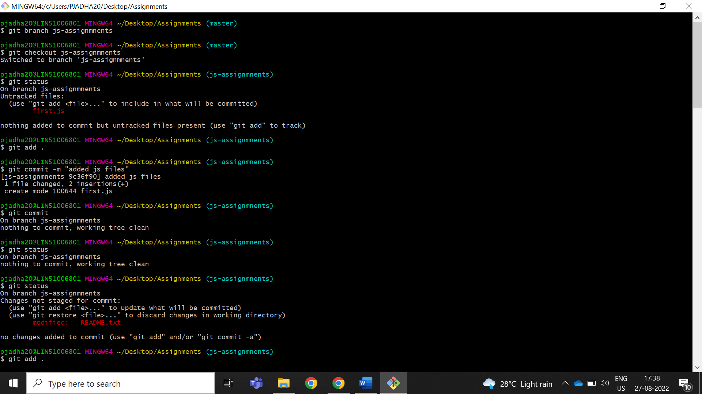

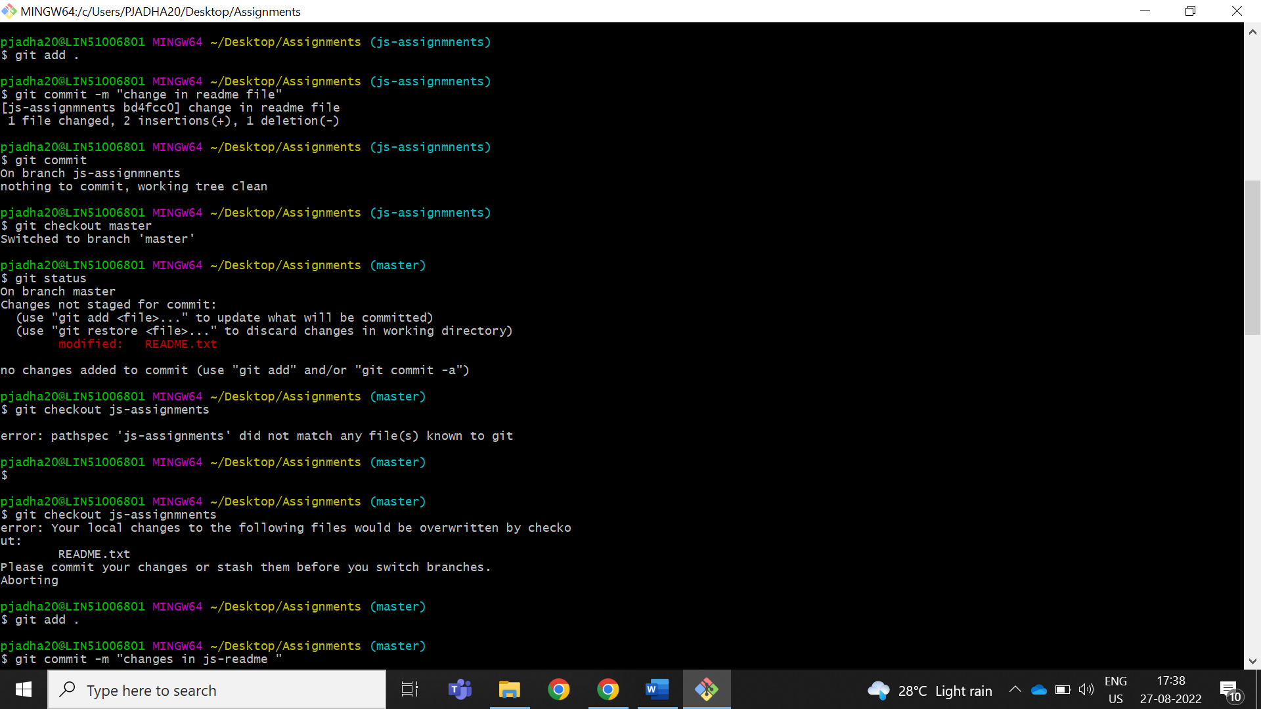

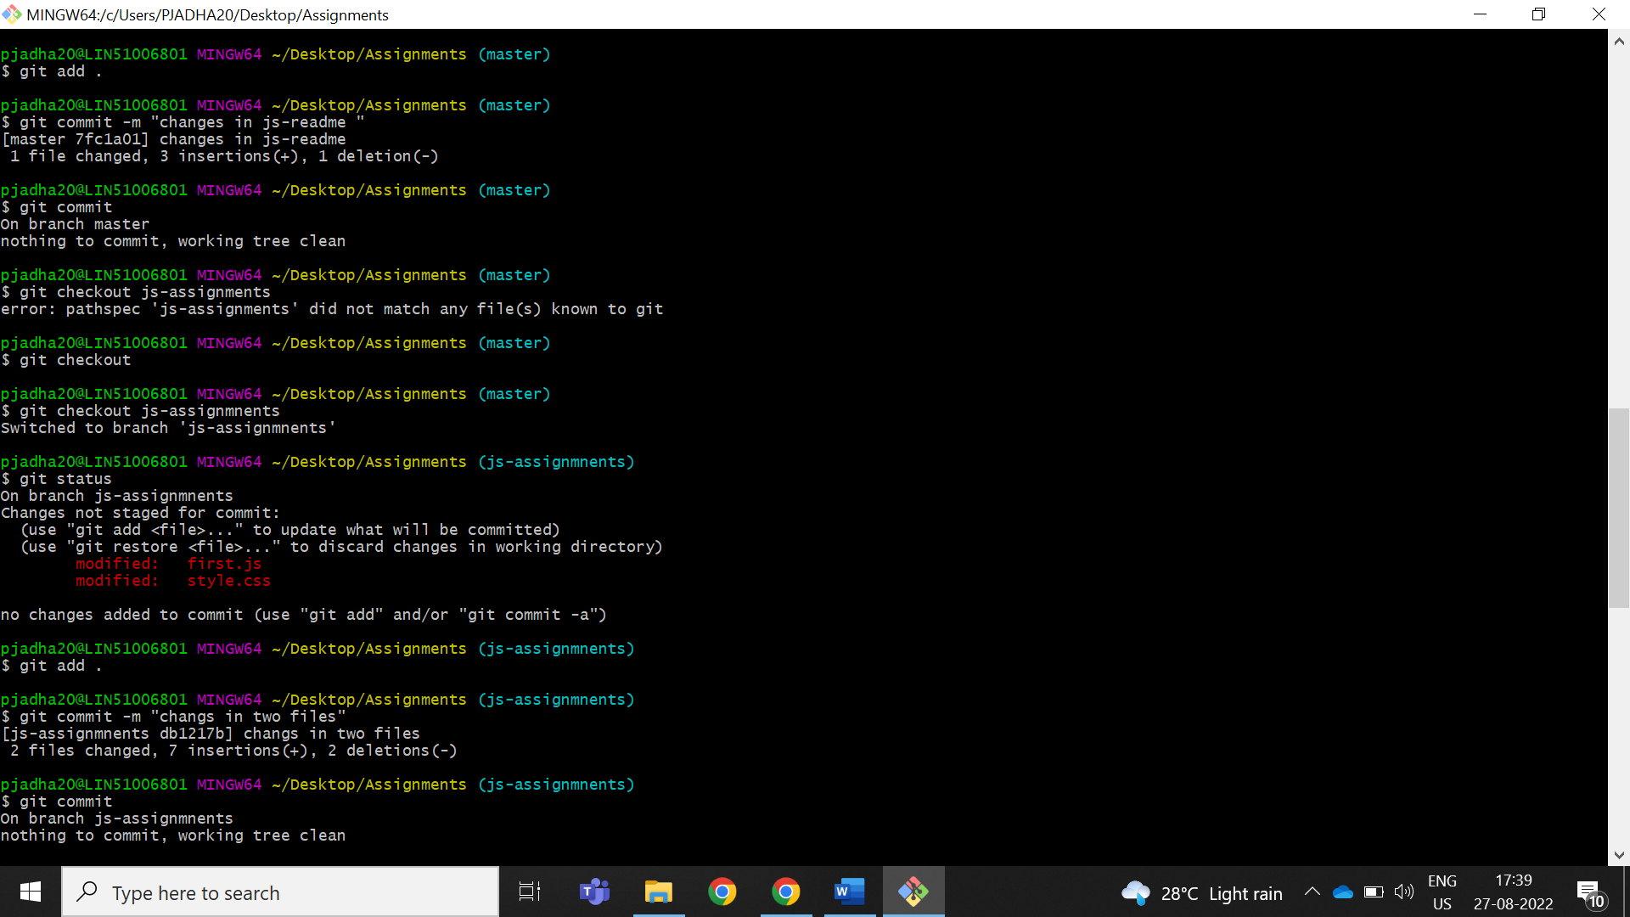

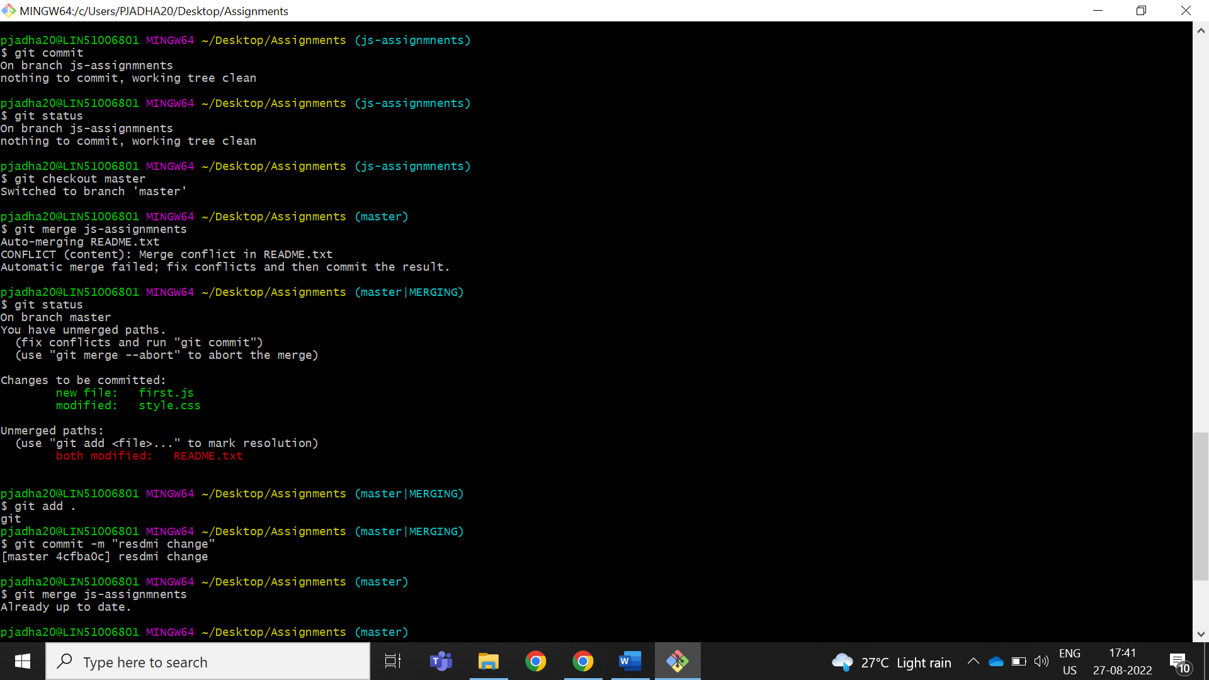

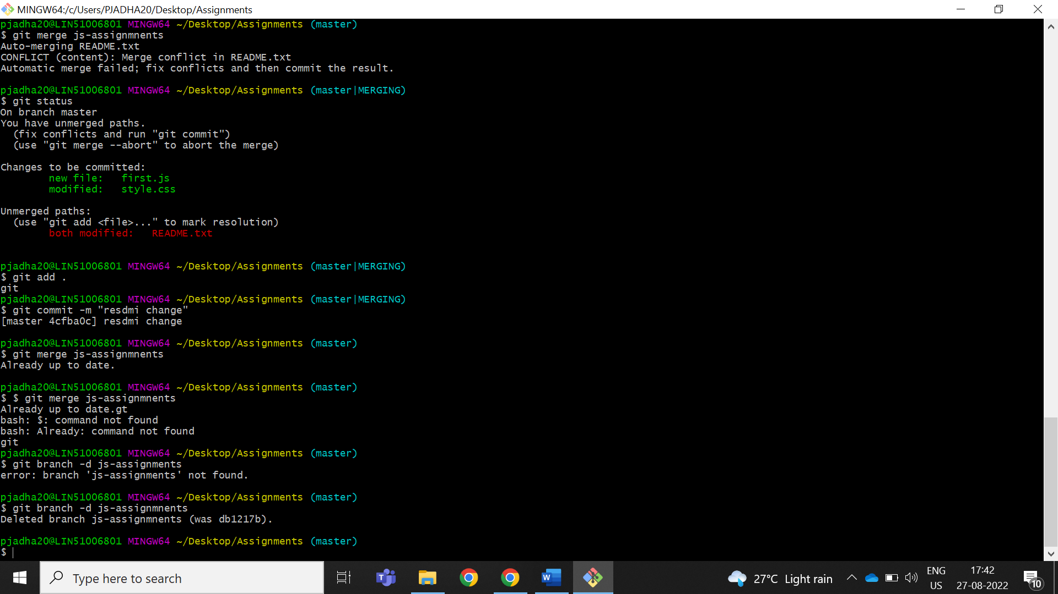

*GIT Remoting*

Objective: Pushing source code into GITHUB & collaborate team members.

SECTION-3 (Pushing assignments to remote repository) - Steps to follow:

1. Create a github account if you do not have already.

Create github account with uername and email id and password

1. Login on into github account.

Login to account with uesrname and password

1. Create new public repository ‘freshersbatch-oct16’.

Goto profile there you can find your repoitory then create repoitory a “Freshsbatch-oct-16”

1. Commit & push any sample file to this repository under ‘Assignments’ directory.

|  |
| --- |
|  |
|  | Create “Freshbatch-0ct16  Create directory mkdir Assignments.  then git init the url copy and pat git |
|  | Git remote add origin “url” |
|  | Git puh remote -v |
|  | Git push -u origin master |
|  | sigin in into git hub |
|  | Give authencation |
|  | Then you can push |

SECTION-4

(Pushing source code to remote repository using Eclipse GIT plugin) - Steps to follow:

1. One developer from project team will create eclipse projects ‘SampleProj’ & add sample source code files. Then commit all files through eclipse GIT plugin.

Answer :1.Open Eclipse IDE then shit to git repository

2.select add on existing local repository

3.Browse the repository folder and add to it.

4.select to clone a repository and enter url and finish.

|  |
| --- |
|  |
|  |
|  |
|  |
|  |
|  |

1. Collaborate other team members with your github account so that they can also modify the committed files.

She collaborated with us by adding Github accounts in the project. I was able to make changes in the files>>Adding and Deleting lines>committing them.

|  |
| --- |
|  |
|  |
|  |

1. Other developers from same team will checkout all files from remote repository. This might get conflicts since certain files fail to merge. In such case, merge it manually.
2. Commit & push the ‘SampleProj’ project.

Answer: 1 . Right click on project

2.select commit

3.We can git staging view then select commit.

4.Then right click on the projrct and select team.

5.In that team memu select push branch master.

|  |
| --- |
|  |